AC220D series DC

isolation filter

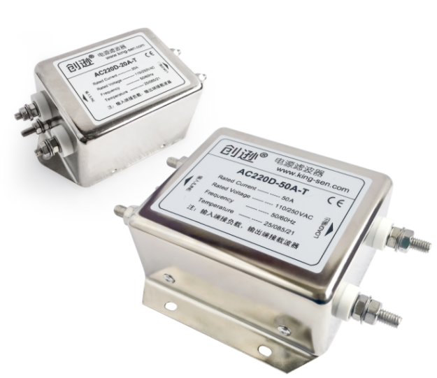 | Features  - Rated current up to 200A（customizable）  - High-performance single-phase bipolar filtering  - Excellent filtering and isolation effects  - Good interference suppression characteristics  - A variety of wiring:bolts,terminal blocks,leads,etc.  - Universal,compact,easy to install  - Safety certification

Application
- Isolation filters are specialised components for power line carrier communication, effectively filtering out interference on power lines while isolating the carrier signal. They provide excellent isolation and filtering performance.
- Isolation filters can resolve issues such as overvoltage, overcurrent, overload, overheating, false tripping, and failure to operate caused by harmonics and surges in the power grid affecting load equipment.
- Isolation filters are connected in series on power lines, installed externally on power line carrier equipment, to block and isolate the impact of grid loads on the equipment and the interference caused to power line carrier communications.
- DC isolation filters are only suitable for use on DC power lines and must not be employed on AC power lines.

Technical conditions (Ratings and Values)
Rated Voltage | 0/400VDC
Operating Frequency | 50/60Hz
Rated Current | 10~50A (More than 50A can be customized)
Filter Range | 10KHz~30MHz
Hi-pot Test | 1450VDC 2sec(Line to Line)  2250VDC 2sec(Line to Ground)
Climatic Category | 25/085/21 (-25°C to +85°C)
Relevant Design Standards | UL 1283, CSA 22.2 No. 8 1986,  IEC/EN60939

Electrical Schematic

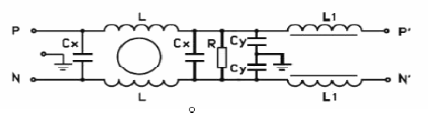
Fig 1

Type Selection Table

Item No. | Rated current(A) | Leak current  (≤mA) | Circuit diagram | Shape size | Outgoing terminal mode  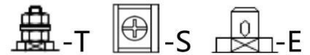
AC220D-10A | 10A | 1 | Fig 1 | T1/S1/E | M4 | M4 | √
AC220D-20A | 20A | 1 | Fig 1 | T1/S1 | M4 | M4 | -
AC220D-30A | 30A | 1 | Fig 1 | T3/S3 | M4/M6 | M4 | -
AC220D-50A | 50A | 1 | Fig 1 | T5 | M4/M6 | - | -
AC220D-80A | 80A | 1 | Fig 1 | T7 | M8 | - | -
AC220D-100A | 100A | 1 | Fig 1 | T7 | M8 | - | -
AC220D-150A | 150A | 1 | Fig 1 | T9 | M10 | - | -
AC220D-200A | 200A | 1 | Fig 1 | T11 | M10 | - | -
Remark：
- Selection method of filter：Calculate the maximum load current value of the power line,multiply by 1.5 times，the corresponding value is the filter current value.
- Default connection mode：Bolt，if you need other wiring can be customized, such as : wire, copper, terminal row, etc.
- The filter current is more than 50A，it can be customized according to the needs, the maximum current can reach 200A.

Outline Dimensions(mm)
Insert \E  10A | 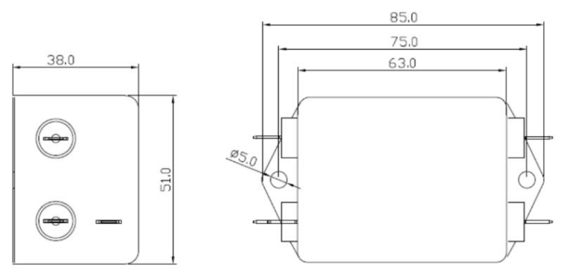
Terminal block\S1  10A/20A | 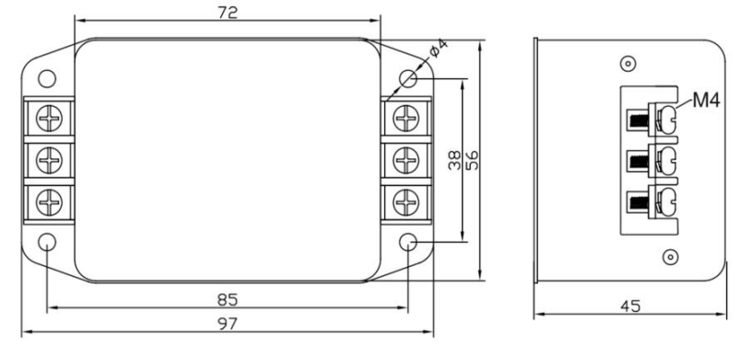
Bolt/T1  10A/20A | 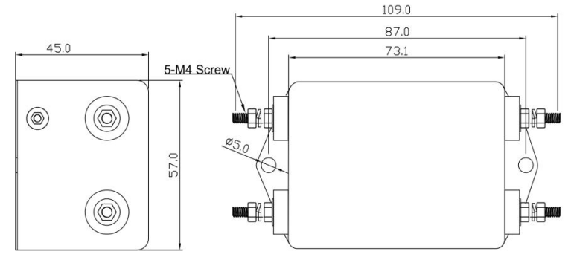
Terminal block\S3  30A | 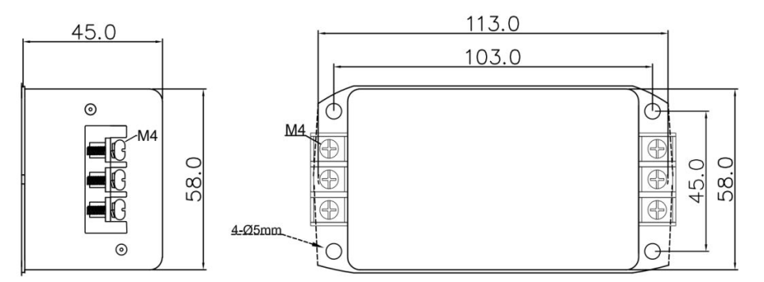
Bolt\T3  30A | 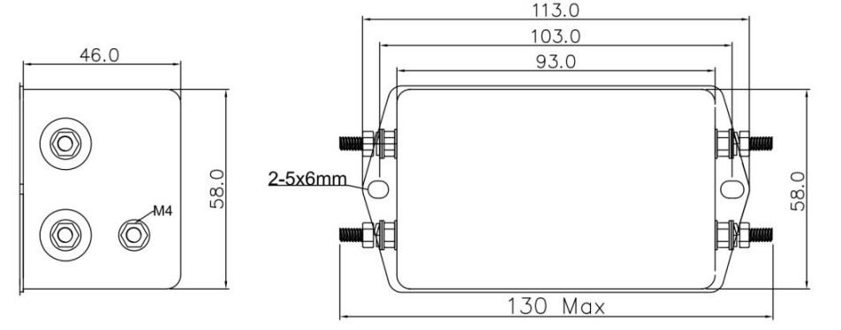
Bolt \T5  50A | 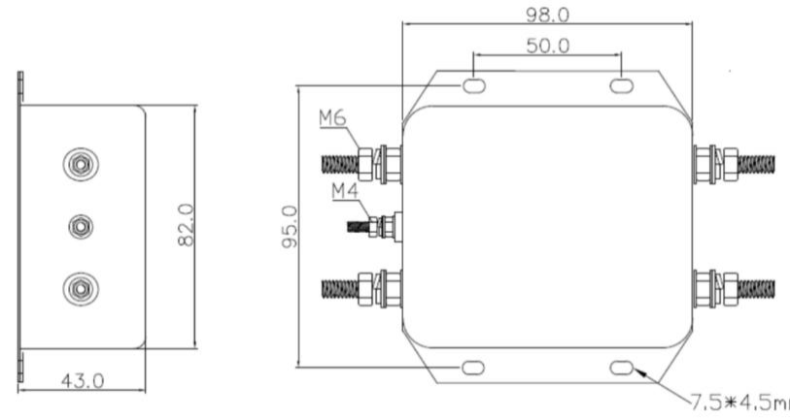
Bolt \T7  80A/100A | 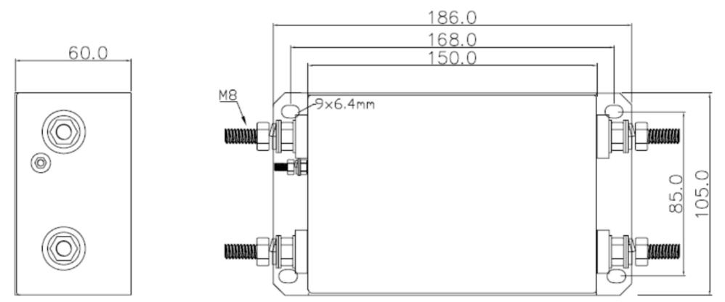
Bolt \T9  150A | 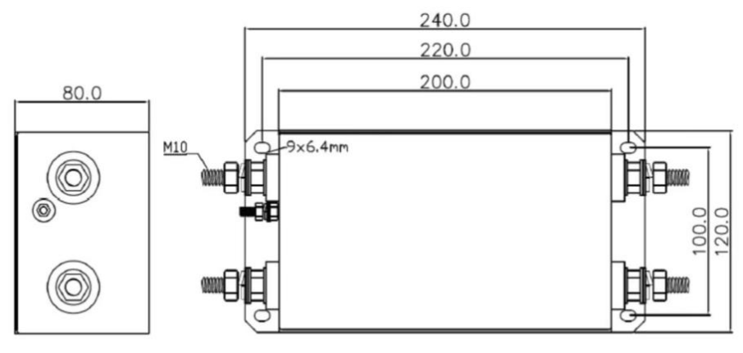
Bolt \T11  200A | 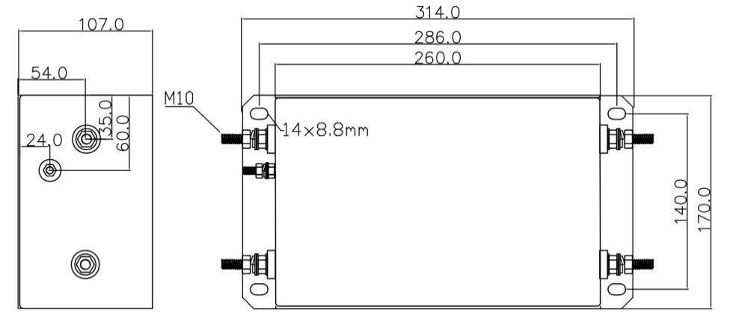

Wiring method
In practical power carrier applications，there will be large loads on the power lines，for example, regulated power supplies, inverters, servos, large capacitors, inductive loads, etc，these can have a large absorption effect on the high frequency signals of broadband power carriers.To avoid degradation of power carrier performance，to achieve the desired power carrier effect，it is highly recommended to install special isolation filters at both ends of the power line，impedance wave isolation is performed on the interference source.
Connection method of power filter in series on power line：
1.Main Control Cabinet: The output terminals of the main circuit breaker are connected in series with the input terminals (LINE) of the isolation filter, while the output terminals (LOAD) serve as the power supply output. The broadband carrier is connected in parallel to the output terminals (LOAD) of the isolation filter.
2.Electrical Control Sub-Cabinet: The output terminal (LOAD) of the isolation filter at the electrical control sub-cabinet end serves as the power input, connected in series with the output terminal (LOAD) of the filter at the electrical control main cabinet end. The input terminal (LINE) functions as the power output, connected in series with the load equipment. The broadband carrier is connected in parallel to the output terminal (LOAD) side of the isolation filter.
The single-phase isolation filter wiring diagram is as follows：

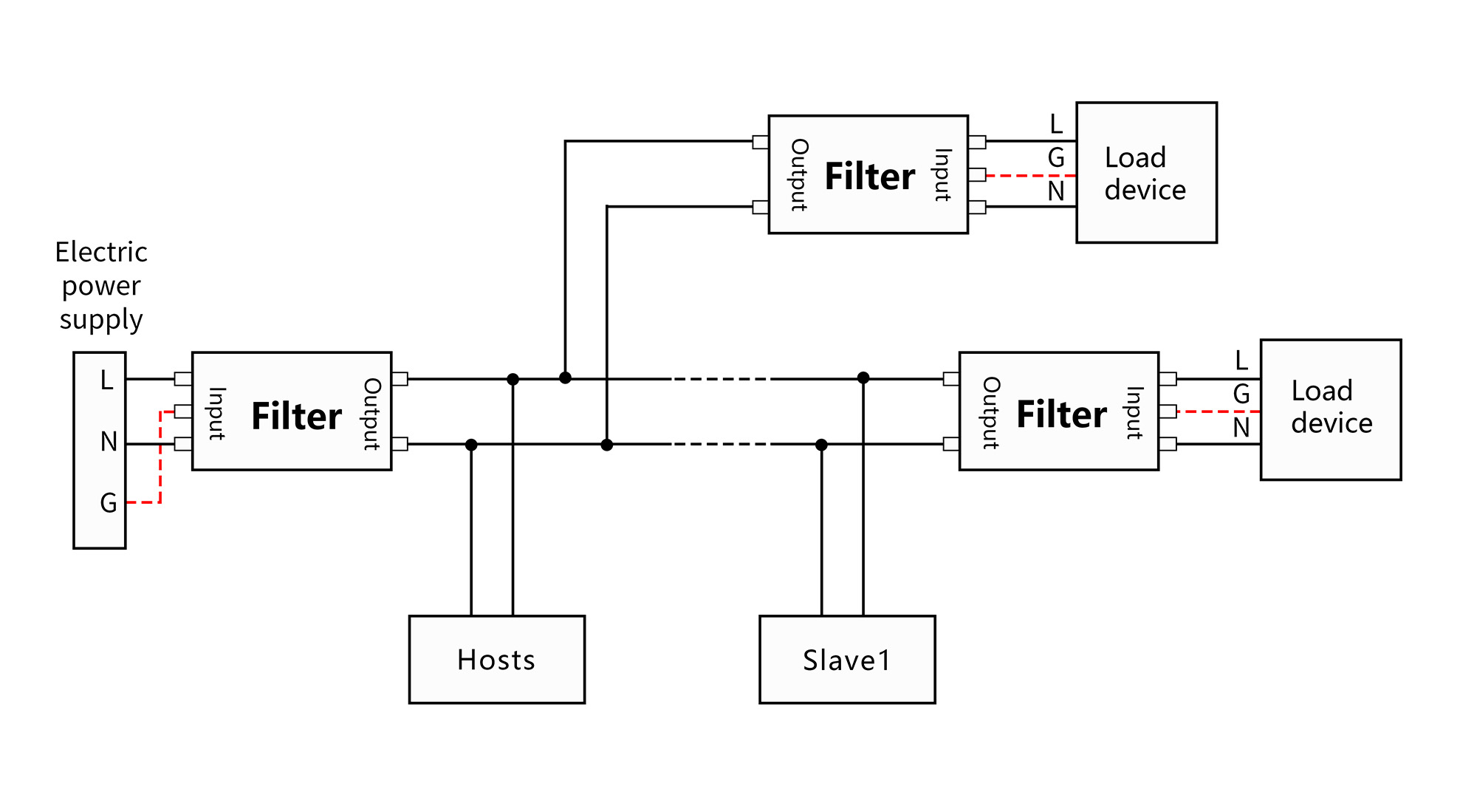

Notice：
The isolation filter serves as a dedicated isolator for power line carrier applications. Its wiring requires directional distinction: the power supply for isolation filters in the main electrical control cabinet flows from input to output, whereas for isolation filters in sub-control cabinets, the power supply flows from output to input. Isolation filters in sub-control cabinets must be wired in reverse: the output terminal connects to the power supply input, and the input terminal connects to the load.

Isolation filters shall be fitted externally to all broadband carrier units. Broadband carrier units shall be connected in parallel across the power lines at the outputs of the isolation filters; isolation filters shall not be fitted between carrier units.

All loads on the power line carrier circuit should be fitted with isolation filters to ensure broadband carrier communication operates over clean power lines.

The isolator should be installed as close as possible to the power cable entry point and the load end to filter out electromagnetic interference entering and escaping along the power cable.

The input and output lines of the isolation filter should be spaced apart; they must not be routed in parallel or cross each other, as this would impair the filter's performance.

The earth connection for isolation filters must not be left floating; it must be connected to an earth wire or to a metal casing. The earth connection should be as short as possible.

Danger of electric shock: Never operate while energised; never touch the terminals directly. The isolation filter contains energy-storage components; hazardous voltages may persist for up to 10 seconds after disconnection.

Contact Us
 | Business Phone： 18157343325 Lila Xu  Technical Phone：18057302496 Wailly Yang  E-mail：sales@king-sen.com  Office website：www.asyjx.com  Address：Room 302, Building 11, No. 79 Jinsui Road, Economic and Technological Development Zone, Jiaxing , Zhejiang P.R. China
*This information product images and technical data is for reference only, if subject to update without prior notice, the specific content of the right to interpret ASY Electronics (Jiaxing) Co., Ltd.

