AC3803BP Series three-phase three-wire

Inverter special power filter
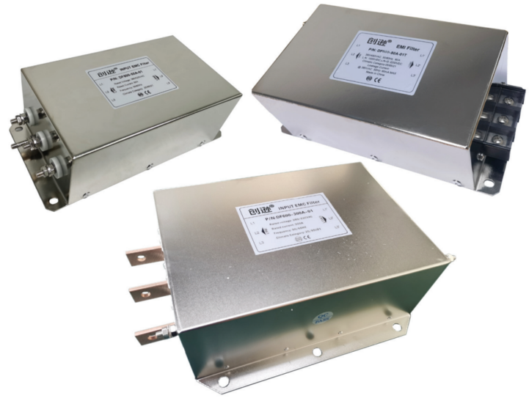 | Features  - Rated current up to 250A  - Designed for frequency inverters and especially for severe interference  - Excellent filtering and isolation effects  - Directly matches various brands of frequency converters,inverters,servos,industrial drive systems  - Various wiring options available：bolt，copper，terminal block  - Safety certification
Application
- The power filter is suitable for three-phase three-wire power carrier with servo, inverter or large driver，not only can it effectively filter out the impact of interference on the power line on the power carrier，and it can isolate the carrier signal，it has secondary filtering effect.
- Power supply filter mounted on the outside of the carrier，used to cut off and isolate the interference of inverters, servo drives or large drives, etc. on power carriers.
- Where there is load, it is necessary to connect the power filter in series，to solve the problems of over-voltage, over-current, overload, heating, misoperation and rejection of frequency converter caused by harmonics and surges in power grid.
- Suitable for domestic and foreign different brands of inverter, servo, industrial drive system supporting use.
Technical Data
Rated Voltage | 380/440VAC
Operating Frequency | 50/60Hz
Rated Current: | 5~250A
Filter Range | 10KHz~30MHz
Hi-pot Test | 2250VDC, 2 sec (Line to Line)  2700VDC, 2 sec (Line to Ground)
Climatic Category | 25/085/21 (-25°C to +85°C)
Overload Capability | 4x rated current at switch on,  1.5x rated current for 1minutes, once per hour
Design corresponding to | UL 1283, CSA 22.2 No. 8 1986, IEC/EN 60939

Electrical Schematic

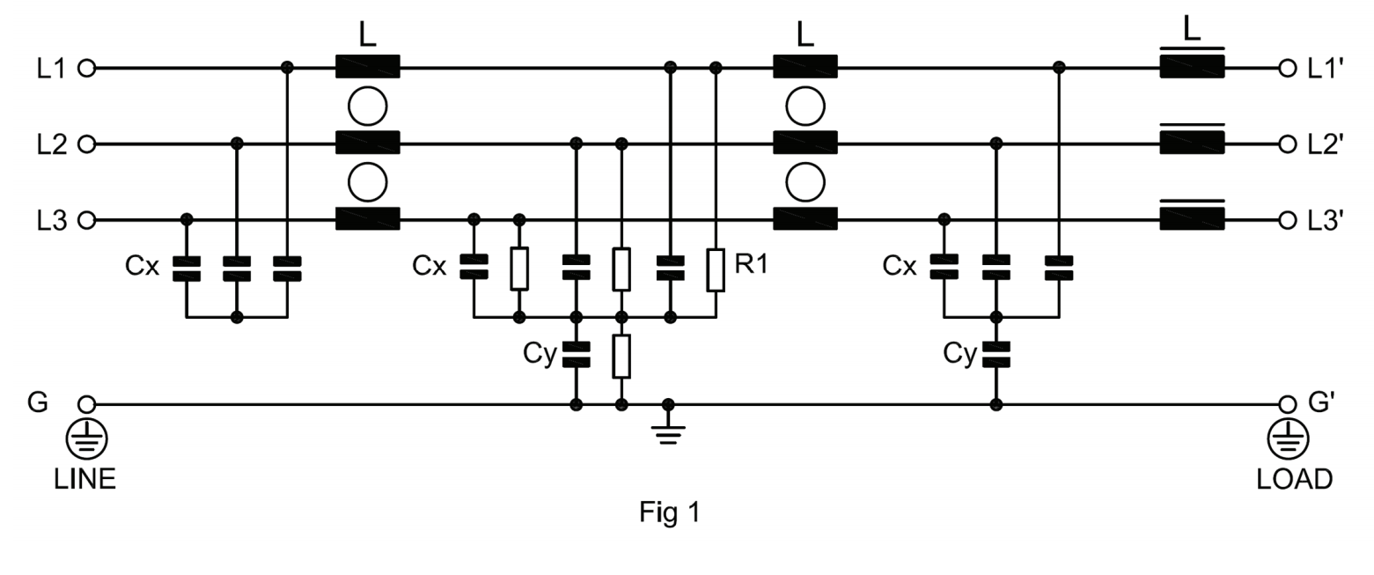

Type Selection Table
Item No. | Rated current(A) | Leak current(≤mA) | Inverter/Server Capacity (KW) | Shape size | Outgoing terminal mode   |  |  | Weight  (KG)
AC3803BP-8A-T | 8 | 10 | 2.2/3.7 | N2 | M4 | M4 | - | 1.1
AC3803BP-16A-T | 16 | 20 | 5.5/7.5 | N5 | M6 | M4 | - | 1.4
AC3803BP-30A-T | 30 | 20 | 11/14 | N5 | M6 | M4 | - | 1.6
AC3803BP-45A-T | 45 | 40 | 18.5/22 | N10 | M6 | M6 | - | 2.5
AC3803BP-60A-T | 60 | 40 | 30 | N10 | M6 | M6 | - | 3
AC3803BP-75A-T | 75 | 50 | 37 | N12 | M8 | M6 | - | 6.5
AC3803BP-100A-T | 100 | 50 | 45 | N12 | M8 | M6 | - | 7
AC3803BP-120A-T | 120 | 60 | 55 | N12 | M8 | M6 | - | 7
AC3803BP-150A-T | 150 | 60 | 75 | N12 | M10 | M6 | - | 10
AC3803BP-200A-T | 200 | 60 | 90 | N12 | M10 | M8 | - | 10
AC3803BP-250A-T | 250 | 60 | 110 | N15 | M10 | M8 | - | 10
Remark：
- Selection method of filter：Calculate the maximum load current value of the power line,multiply by 1.5 times，the corresponding value is the filter current value.
- Default connection mode：Bolt，if you need other wiring can be customized, such as : wire, copper, terminal row, etc.
- Filter current can be customised as required，the maximum current is up to 250A.

Outline Dimensions(mm)
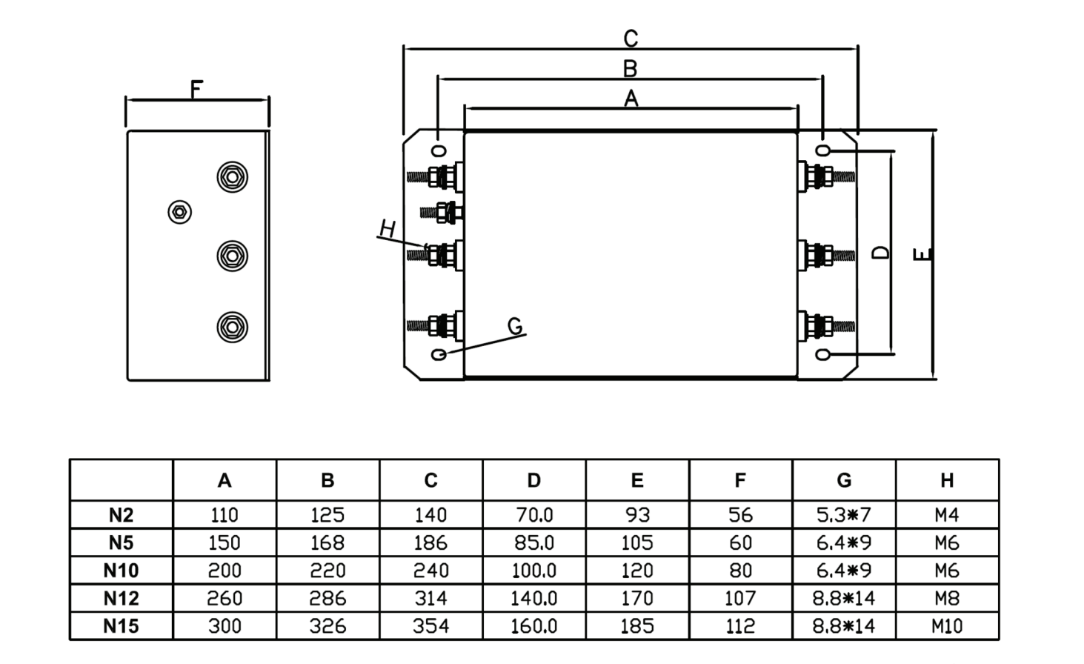

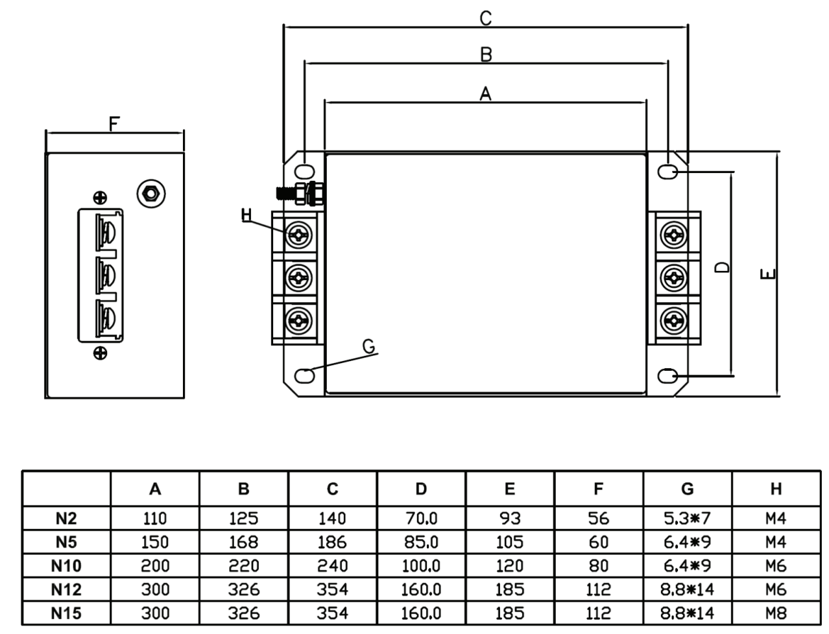

Wiring method

In practical power carrier applications，there will be large loads on the power lines，for example, regulated power supplies, inverters, servos, large capacitors, inductive loads, etc，these can have a large absorption effect on the high frequency signals of broadband power carriers.To avoid degradation of power carrier performance，to achieve the desired power carrier effect，it is highly recommended to install special power filters at both ends of the power line，impedance wave isolation is performed on the interference source.
Connection method of power filter in series on power line：
1.Electric control main cabinet:The outlet of the main air switch is connected in series with the input of the power filter（LINE），output side（LOAD）is parallel to PLC，at the same time, the output side of the filter at the end of the electric control sub- cabinet is connected in series.
2.Electric control sub- cabinet：The output end of the electronic control sub- cabinet filter ( LOAD ) is connected in series with the input end of the electronic control main cabinet filter ( LINE )，parallel to the carrier at the same time.Input side( LINE ) and load equipment are connected in series.

The three-phase power filter wiring diagram is as follows：

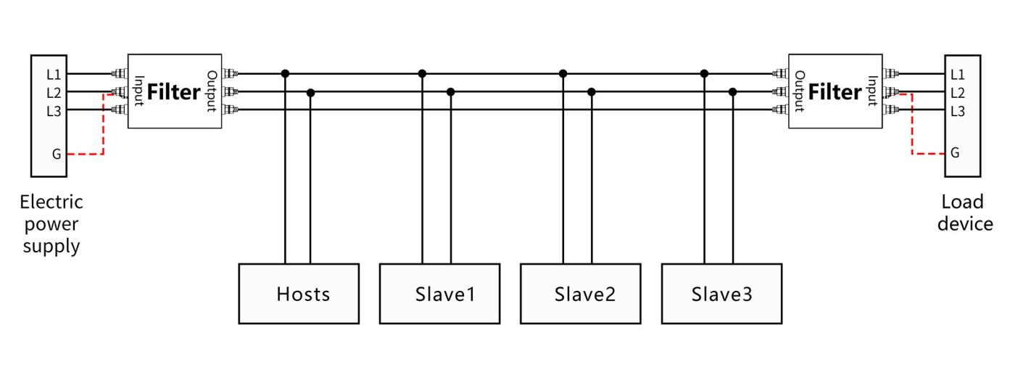

Notice：
Power filters are special isolators for power carriers，different from general power filter，the isolator needs to distinguish direction.The power supply or load side is connected to the isolator input side，the output end is relatively series connected.The carrier is connected in parallel on the power line between the outputs of the isolator.
Isolators are required at both sides of the power line.The input of power supply filter is connect to power supply input，the output side is connected to the power output，the carrier is paralleled at the output end.The load side filter needs reverse wiring，the output side is connected to the power input and parallel carrier is connected，the input side is connected to the power output，with load equipment.
All loads on the power line carrier loop should be equipped with isolators，ensure power line carrier communication on clean power lines.
Isolators added to the outside of all power carriers，there must be no isolators between carriers.
The isolator should be mounted as close as possible to the power line inlet and the load side，filtering of electromagnetic interference along the power line ingress and egress.
The input and output wires of the power supply filter should be pulled apart，do not parallel or cross line，in order to avoid reducing the filtering performance.
The ground wire of power filter cannot be suspended，must be grounded or connected to a metal housing，the shorter the grounding line, the better.
Electrocution hazard：Do not operate with power on，do not touch the terminal directly.Power filters with energy storage components，there may still be a dangerous voltage on the isolator terminal for 10 seconds after power failure.

Contact Us
 | Business Phone： 18157343325 Lila Xu  Technical Phone：18057302496 Wailly Yang  E-mail：sales@king-sen.com  Office website：www.asyjx.com  Address：Room 302, Building 11, No. 79 Jinsui Road, Economic and Technological Development Zone, Jiaxing , Zhejiang P.R. China
*This information product images and technical data is for reference only, if subject to update without prior notice, the specific content of the right to interpret ASY Electronics (Jiaxing) Co., Ltd.

